**PHP Lab Works**

**Q.1 Create a PHP program to input user details from the form and insert the user data to the database table.**

**STEP 1: Creating form interface in index.php**

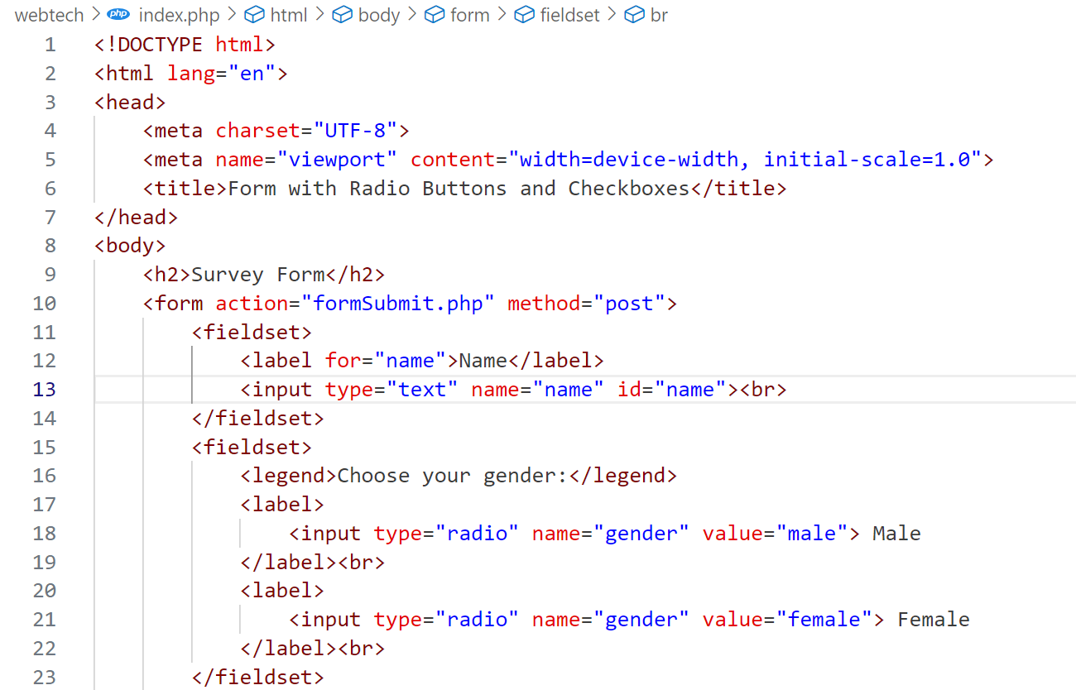

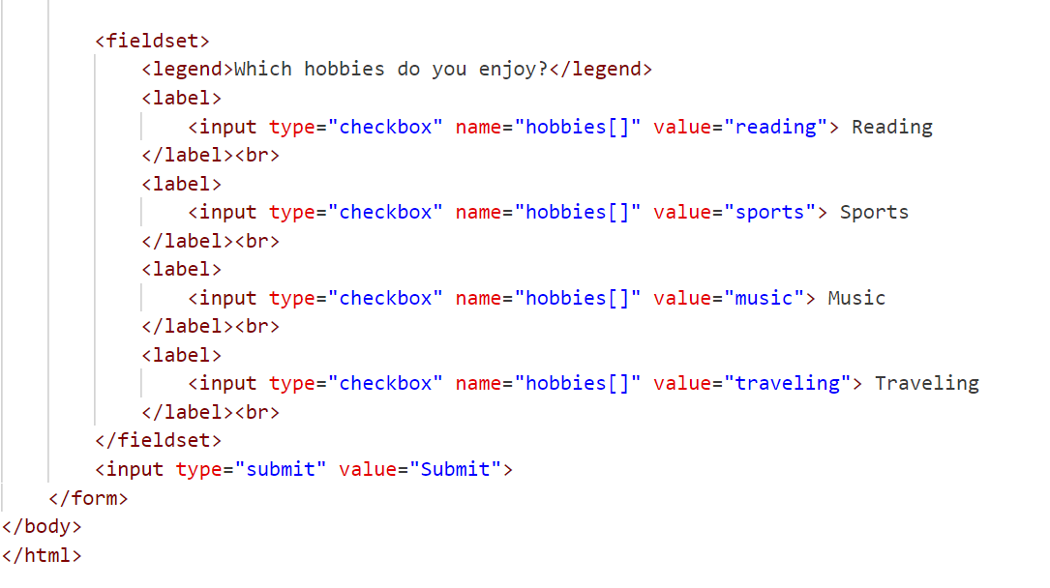

OUTPUT

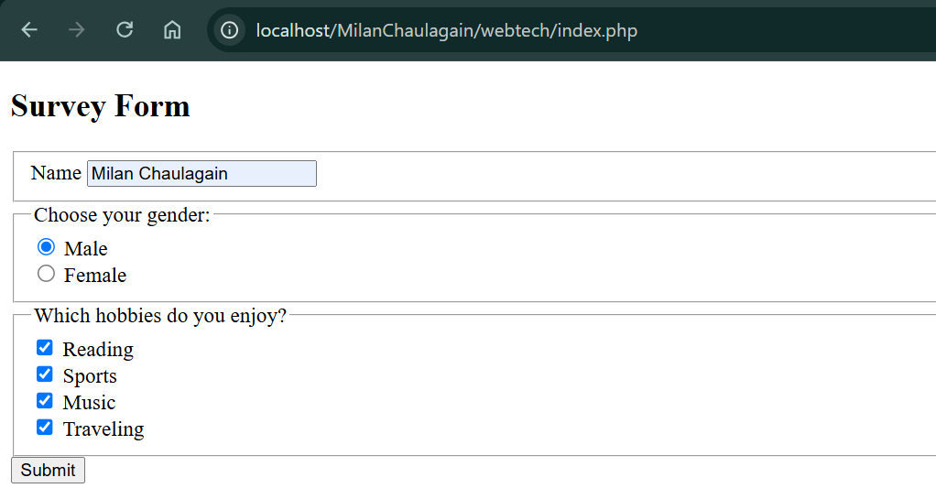

**Step 2: Creating “formSubmit.php” inside the same folder as index.php.**

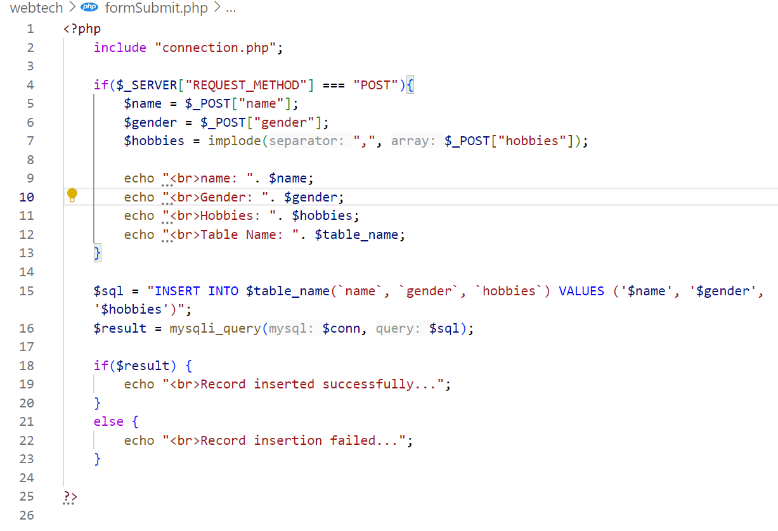

**In formSubmit.php we have included connection.php that helps to connect to the database**

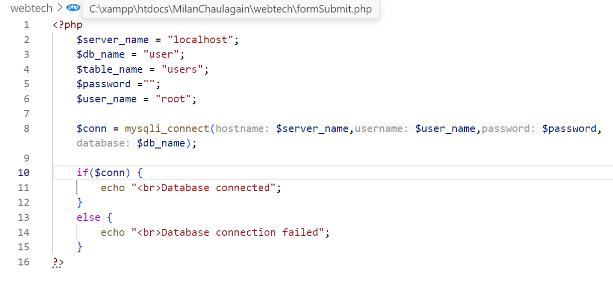

**After the form Submission,**

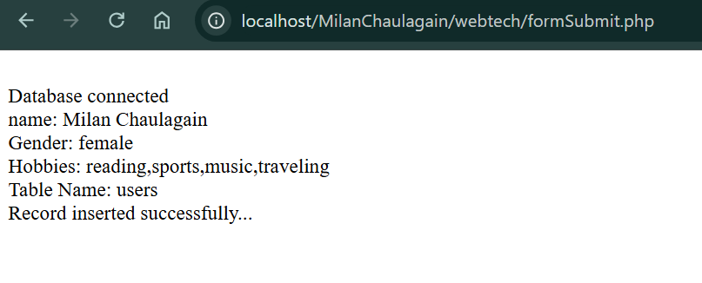

**Database table after inserting records successfully**

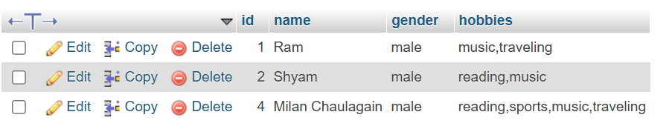

**To display records in a HTML table structure, creating a PHP file “display.php”**

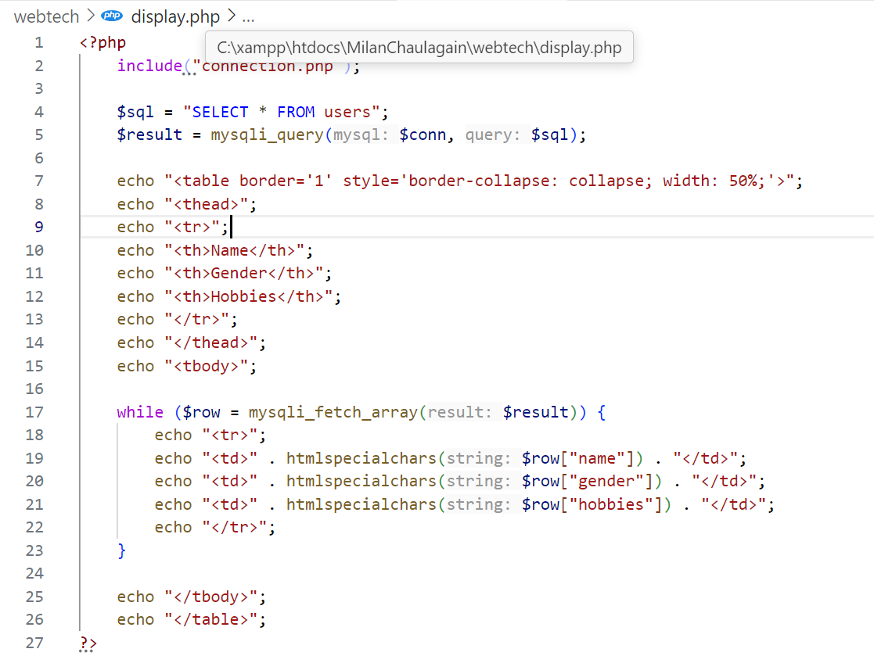

OUTPUT

